Linear Algebra for Machine Learning

Reference: Chapter 2 (Linear Algebra) of the *Deep Learning Book* by Aaron Courville, Ian Goodfellow, and Yoshua Bengio (Attached)

Find the necessary files here > [CSE 472 Assignment 1 Files](https://drive.google.com/drive/folders/147_ftKryKryez20QmwsPFrHJxW5VoDl1?usp=sharing)

# Task 1: Matrix Transformation

Go through and run the notebook “matrix-transformations-and-eigen-decomposition” to get an intuition about

* How a matrix can transform a vector?
* What do columns of matrices mean in terms of transformation?
* What does eigenvector mean?

(We recommend you also read the whole of Chapter 2 of the Deep Learning Book.)

Then,

* Change the cell values of matrix ***M*** so that it does the following shear transformation

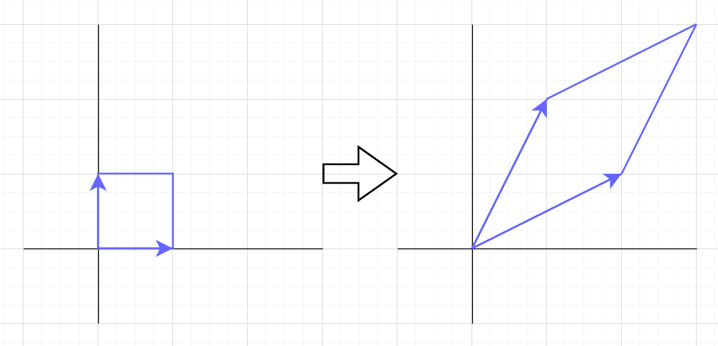

* Run the whole notebook again and submit

# Task 2: Eigen Decomposition

## SubTask 2A: Random Matrix (random_eigen.py)

* Take the dimensions of matrix ***n*** as input.
* Produce a random ***n x n*** invertible matrix ***A***. For the purpose of demonstrating, every cell of ***A*** will be an integer.
* Perform Eigen Decomposition
* Reconstruct ***A*** from eigenvalue and eigenvectors (Refer to Section 2.7).
* Check if the reconstruction is perfect. (np.allclose will come in handy)

## SubTask 2B: Symmetric Matrix (symmetric_eigen.py)

* Take the dimensions of matrix ***n*** as input.
* Produce a random ***n x n*** invertible symmetric matrix ***A***. For the purpose of demonstrating, every cell of ***A*** will be an integer.
* Perform Eigen Decomposition
* Reconstruct ***A*** from eigenvalue and eigenvectors (Refer to Section 2.7).
* Check if the reconstruction is perfect. (np.allclose will come in handy)
* Please be mindful of applying efficient methods

# Task 3: Singular Value Decomposition

## (moore-penrose.py)

* Take the dimensions of matrix ***n, m*** as input.
* Produce a random ***n x m*** matrix ***A***. For the purpose of demonstrating, every cell of ***A*** must be an integer.
* Perform Singular Value Decomposition
* Calculate the Moore-Penrose Pseudoinverse using NumPy’s builtin function
* Calculate the Moore-Penrose Pseudoinverse *again* using Eq. 2.47
* Check if these two inverses are equal (np.allclose will come in handy)

# Submission

1705123

|-- matrix-transformations-and-eigen-decomposition.ipynb

|-- random_eigen.py

|-- symmetric_eigen.py

|-- moore-penrose.py

Zip the folder and rename it to **[Student_ID].zip**

**Deadline: 02 December 2022, Friday 11.55 PM**